**Little Bit Advance Labs**

**Part 2: Hosting a Static Portfolio Website on S3**

**Objective**: Learn to host a static website (such as a personal portfolio) on Amazon S3.

1. **Create an S3 Bucket**: Start by creating a new S3 bucket. Configure the bucket for website hosting, which includes setting permissions to make the content publicly accessible.

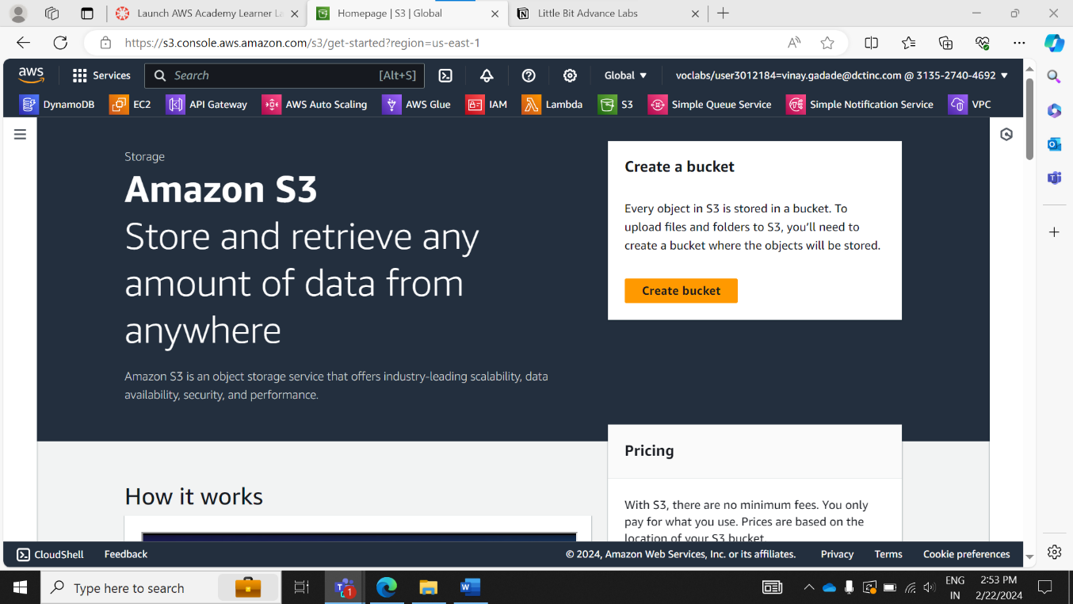

1. **Upload Website Files**: Upload the static files of your portfolio website (HTML, CSS, JavaScript, images) to the S3 bucket.

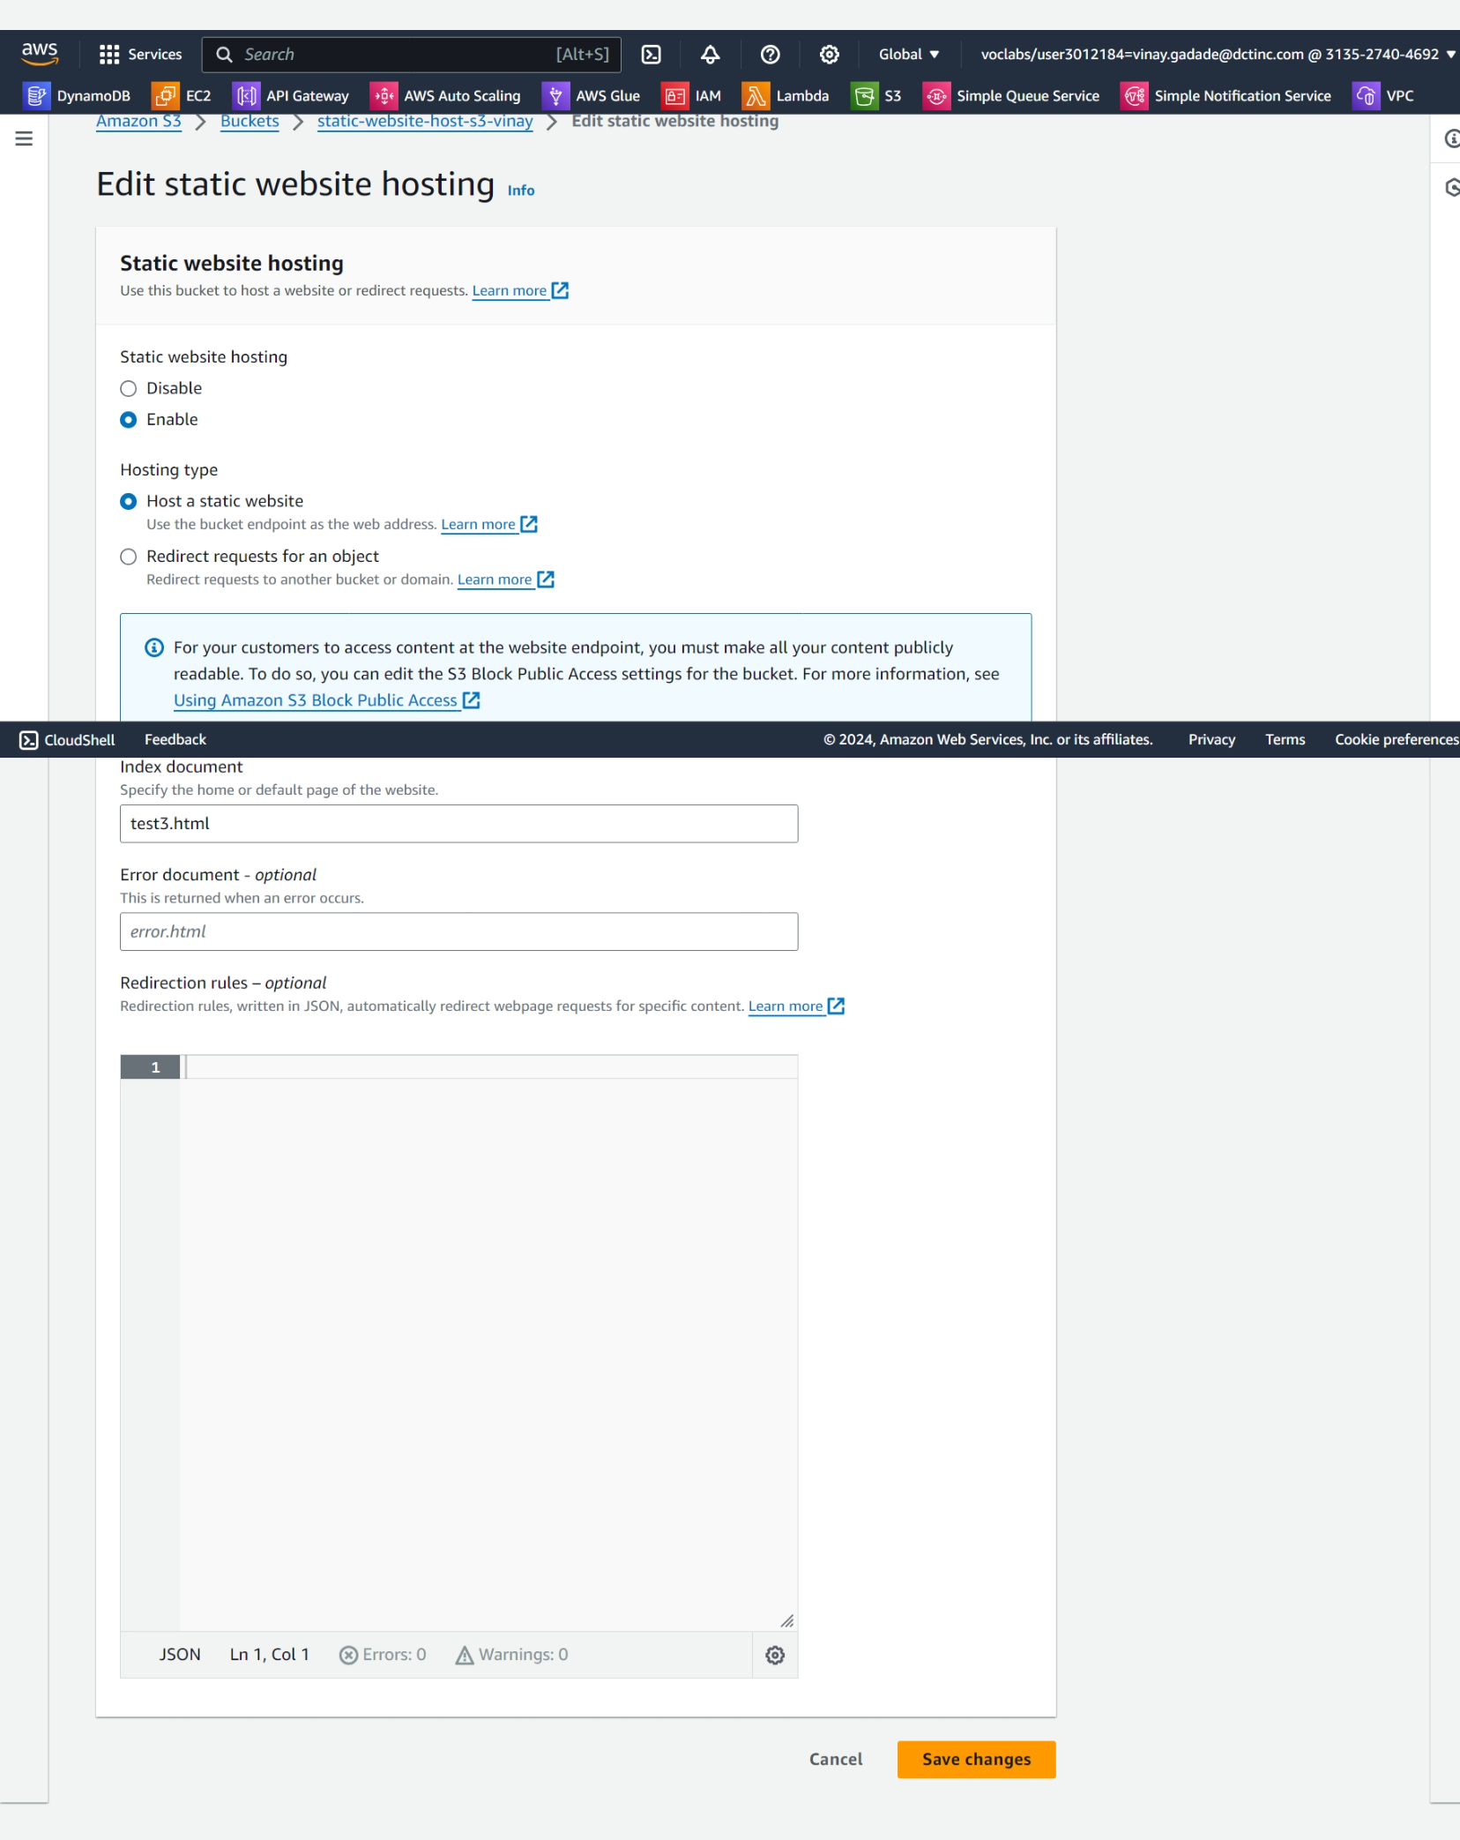

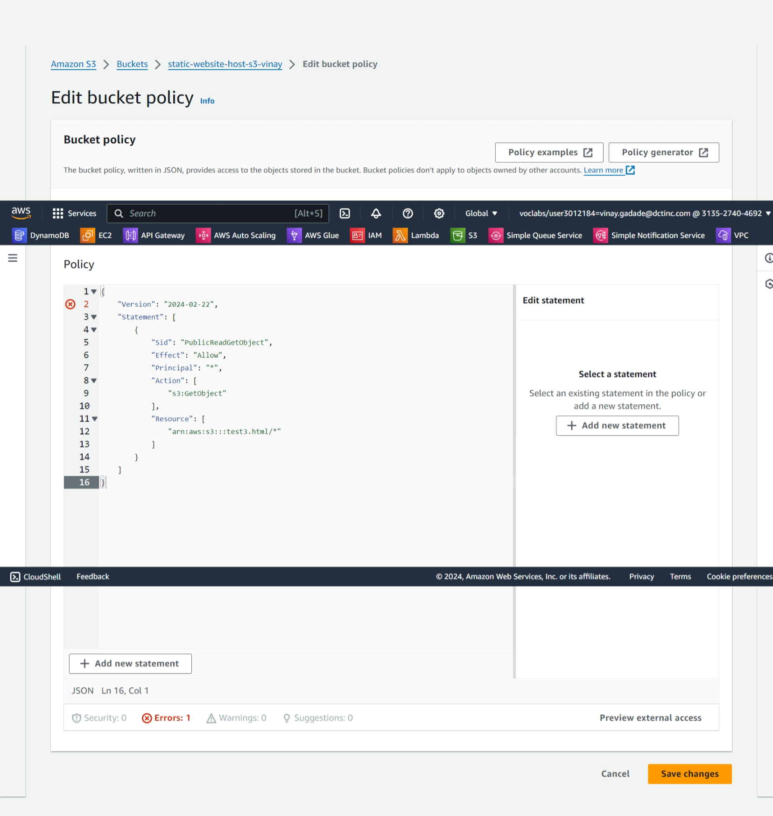

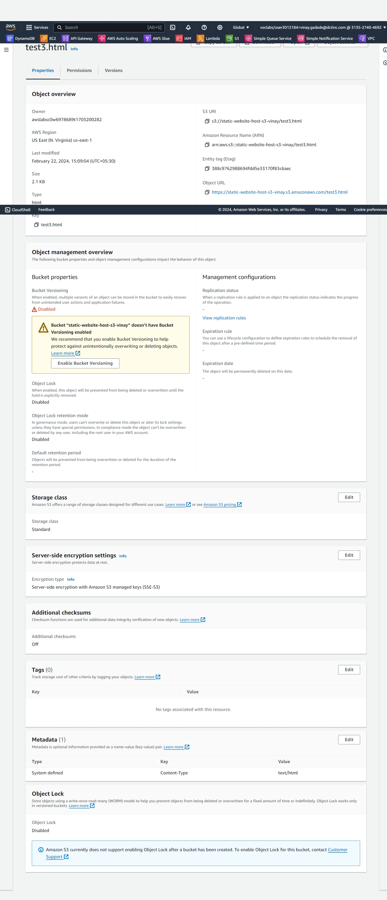

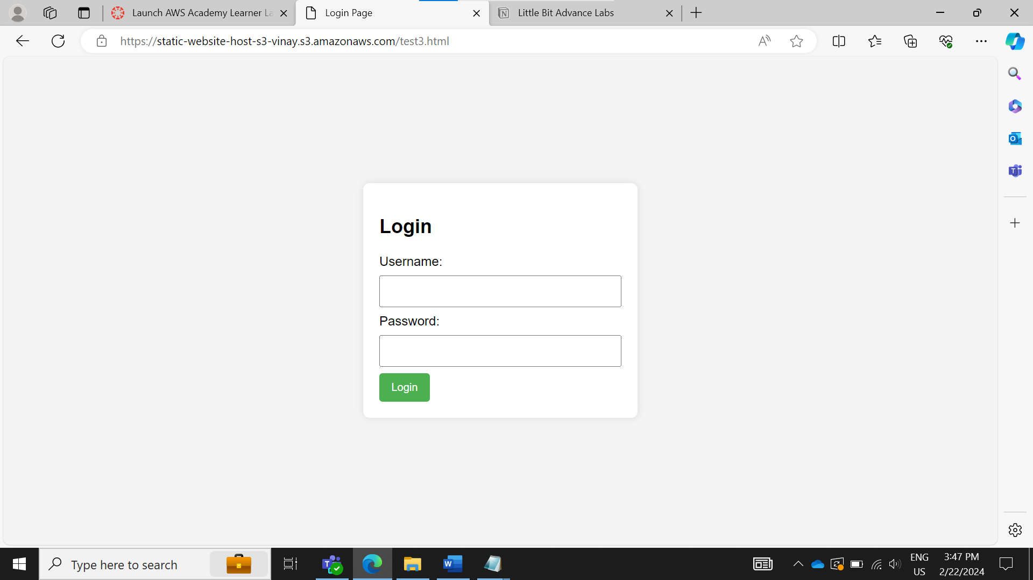

1. Configure DNS: Use Amazon Route 53 or another DNS service to point a domain name to the S3 bucket. This makes the website accessible via a user-friendly URL.

We don’t have a permission to set dns services